REMEMBER THE SICK AND THOSE WHO HAVE ASKED FOR OUR PRAYERS:  Joan B., Della B., Grace C., Kim C., Kathryn F., Viola Mc. C., Kelly Q.,  Elaine D., Russell V., Don H., Janet H.,  Viola B., Audrey N.,  Brian F., Jean-W.C., & David S  Weekly Services  Sunday Morning Service - 10:30 am  Important Dates:  Upcoming Sides People  January 7 – Team 3 – Dave T  January 14 – Team 4 – Jim S  January 21 – Team 1 – Pat C  January 28 – Team 2 – Gail I  Video/PPT Schedule  Bulletin/Flower Memorials  Can be requested by  calling the church office at 576-6632  Deadline for bulletin submissions is:  Wednesday at 2:30 p.m. |  |  | 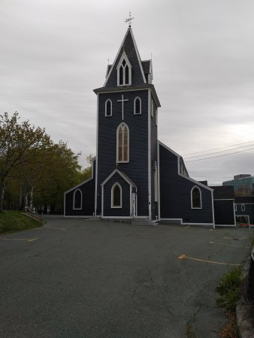  8 Military Road  St. John’s, NL A1C 2C4  Ph.: 709- 576-6632  Fax: 709-737-0472  office@st-thomaschurch.com  http://www.st-thomaschurch.com  Office Hours:  Monday—Friday  9:00 am—2:00 pm.  office@st-thomaschurch.com  Provincial Mental Health Crisis Line – 811:  If you are experiencing a mental health and/or addictions crisis, need support, or health information, please contact 811 to speak with a registered nurse trained in crisis intervention. |  | January 7, 2024  Copyright License  License # 617856  Streaming License # 21364049  Expires 2/29/2024  September 19, Proper 25  Proverbs 31:10-31; Psalm 1;  James 3:13-4:3, 7-8A  Mark 9:30-37  The Bulletin  Vision: To be a radically welcoming servant church.  Mission: A Community of believers,  exploring our faith in Christ and embracing our neighbourhood through  sharing and caring.
PHONE DIRECTORY
Rev. Canon Gail MacDonald
709-730-9290
reverendgail@nl.rogers.com

Parish Administrator -Paulette Hounsell Collins 709-576-6632
paulettehounsellcollins@st.thomaschurch.com

Office Assistant - Jocelyn Power 709-576-6632
office@st-thomaschurch.com

Music Director - Ki Adams— kiadams@mun.ca
Bassist - Tim Caruk
Guitarist - Jayde Eustace

Rector’s Warden - Dave Tipple 709-753-6833
People’s Warden - Eric Albrechtsons
709-687-6187

Archives - Rev. Bob Chafe 709-726-2785
PowerPoint – Daph Crane 709-325-3433
Sexton - Darrin Gosse 709-576-6632
Sidespeople - Jim Skanes 709-739-9483
Sound - Dave Mercer 709-753-6833
Sunday School - Canon Gail 709-730-9290

Honorary Assistants
Rev. Dr. Bob Rowlands, OPA bob@warp.nfld.net
Rev. William Rice
rwilliamrice@gmail.com

PARISH NOTICES PARISH NOTICES NNOTICESNOThttps://www.google.com/url?sa=i&url=https%3A%2F%2Fchristiancamppro.com%2Fthe-constantly-growing-list-of-funny-christian-jokes-with-pictures%2F&psig=AOvVaw0Mo0ewqQn94lpq4WSX-n4L&ust=1654092061909000&source=images&cd=vfe&ved=0CAkQjRxqFwoTCPDZm73zifgCFQAAAAAdAAAAABAEICES CONT…
On behave of Canon Gail and Staff we would like to say Thank You to all who have given the office gifts for Christmas.

Please pickup your 2024 envelopes. They are in the back of the church on the table if you need help, you can ask one of the Sidespersons they would be happy to help you.

Church Calendars have arrived, please see Gail Ivany. Price $6.

As the dawn breaks on a new year, let us give thanks for all we hold dear: our health, our family and our friends. Let us release our grudges, our anger and our pains, for these are nothing but binding chains. Let us live each day in the most loving ways, the God-conscious way.

Today’s bulletin is dedicated in loving memory of Fraser M. Kirby, by his wife, Sadie Kirby & Family.
____________________________________________
We acknowledge with thanks gifts for the Christmas season (received after Dec. 18/23) to the Glory of God and in loving memory of:

Mother, Joyce Snow; Brothers, Randy, Carl & Robin from Glenda Smart & Eric Snow

Steve Wickens & John Smith from
Linda Mugford

Blanche & Charles Rodgers; Sherbrooke Rodgers, from Fraser Rodgers
______________________________________

Welcome to our Church: Whoever you are, and wherever you find yourself in your journey of faith, you will find a place at our table at St. Thomas’ Anglican Church. Come as you are. There are many ways and there is no one particular way to be a part of this vibrant community. Join us today with an open mind, and be prepared to discover a home for your spirit that is inclusive, incarnational, and joyful.
Our worship services may be live-streamed. If you have any concerns about this, please inform one of the Sidespeople at the door.

Hymn Requested Requested By In Memory of: Laura Carter
How Great Thou Art - Penny Gillespie
Come Let Us Sing of a Wonderful Love – Penny Gillespie

